**rishik**

**192121080**

**R programming**

**Assignment 2**

**1.** **The built-in vector LETTERS contains the uppercase letters of the alphabet. Produce a vector of**

1. **the first 12 letters;**
2. **the odd ‘numbered’ letters; (iii) the (English) consonants.**

**Program:**

1. **the first 12 letters;**

**first12 <- LETTERS[1:12] print(first12) output:**

first12 <- LETTERS[1:12]

> print(first12)

[1] "A" "B" "C" "D" "E" "F" "G" "H" "I" "J" "K" "L"

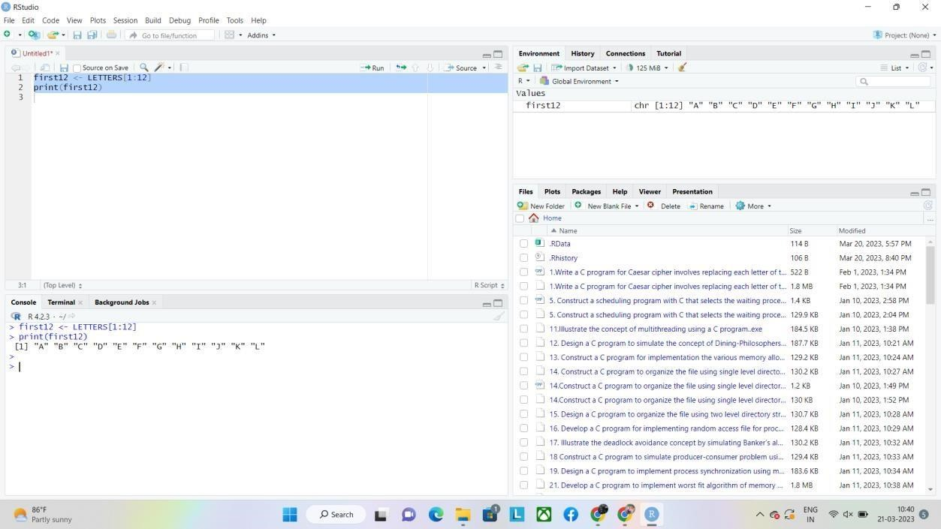

1. **the odd ‘numbered’ letters; Program:**

**odd_letters <- LETTERS[seq(1, length(LETTERS), 2)] print(odd_letters)**

**Output:**

odd_letters <- LETTERS[seq(1, length(LETTERS), 2)]

> print(odd_letters)

 [1] "A" "C" "E" "G" "I" "K" "M" "O" "Q" "S" "U" "W" "Y"

>

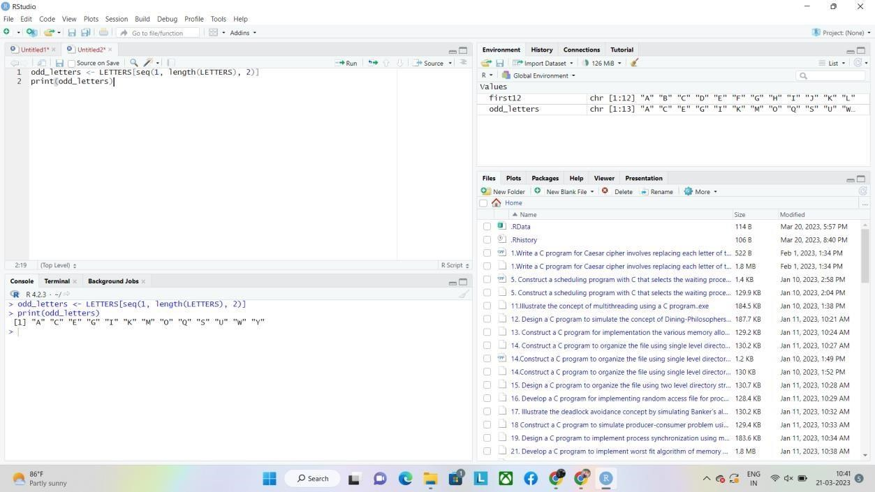

**(iii) the (English) consonants.**

**Program:**

**vowels <- c("A", "E", "I", "O", "U")**

**consonants <- LETTERS[!LETTERS %in% vowels]**

**print(consonants) output:**

> vowels <- c("A", "E", "I", "O", "U")

> consonants <- LETTERS[!LETTERS %in% vowels]

> print(consonants)

[1] "B" "C" "D" "F" "G" "H" "J" "K" "L" "M" "N" "P" "Q" "R" "S" "T" "V" "W" "X" "Y" "Z>

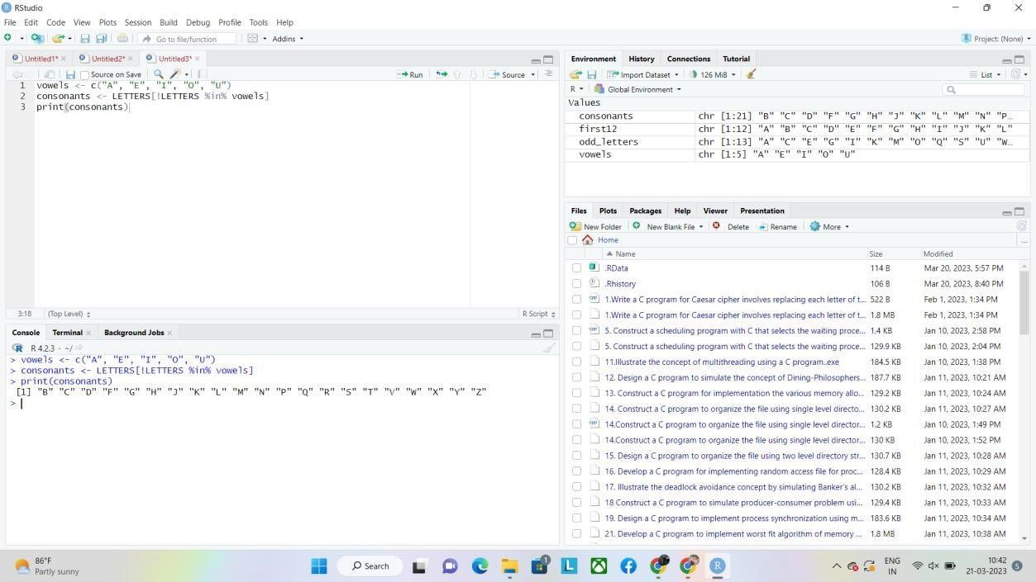

**2.**  **The function rnorm() generates normal random variables. For instance, rnorm(10) gives a vector**

**of 10 i.i.d. standard normals. Generate 20 standard normals, and store them as x. Then obtain**

**subvectors of**

1. **the entries in x which are less than 1;**
2. **the entries between – 0.5 and 1;**
3. **the entries whose absolute value is larger than 1.5.**

**Program:**

**(i) the entries in x which are less than 1;**

**# set seed for reproducibility set.seed(123)**

**# generate 20 standard normals x**

**<- rnorm(20)**

**# get subvector of entries in x which are less than 1 less_than_1 <- x[x < 1] print(less_than_1).**

**Output:**

> # set seed for reproducibility

> set.seed(123)

>

> # generate 20 standard normals

> x <- rnorm(20)

>

> # get subvector of entries in x which are less than 1

> less_than_1 <- x[x < 1]

> print(less_than_1)

[1] -0.56047565 -0.23017749 0.07050839 0.12928774 0.46091621 -1.26506123 -

0.6868528

[8] -0.44566197 0.35981383 0.40077145 0.11068272 -0.55584113 0.49785048 -1.9666171 [15] 0.70135590 -0.47279141

>

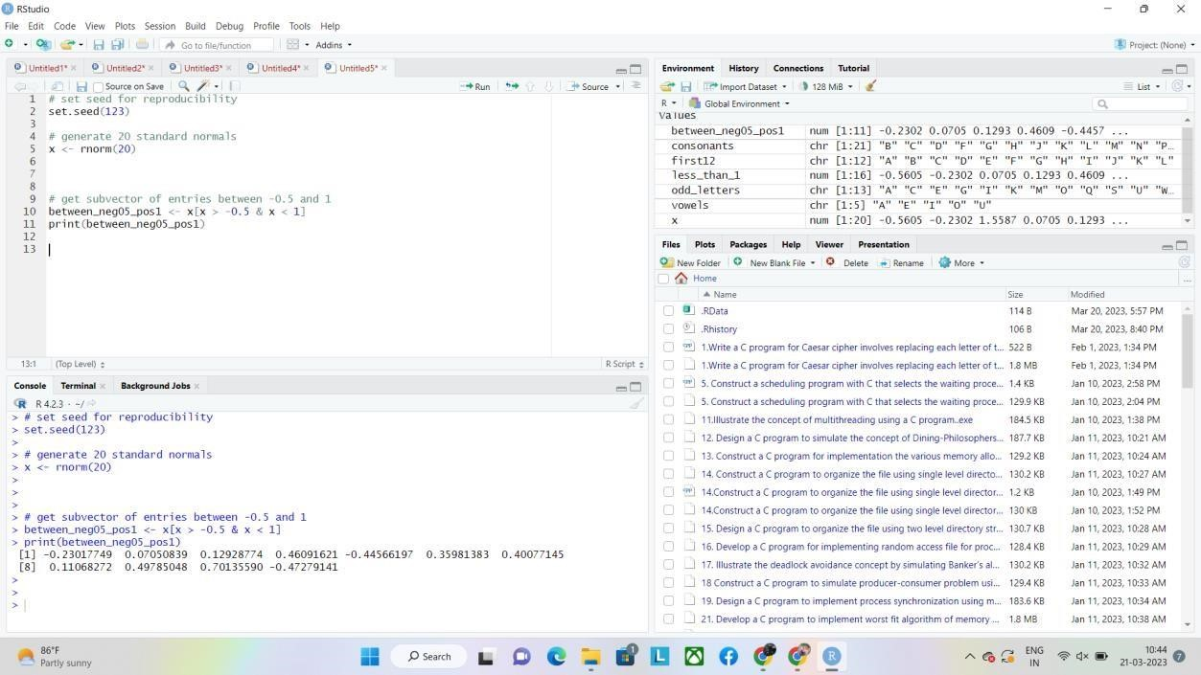 **Program:**

**(ii) the entries between – 0.5 and 1; # set seed for reproducibility set.seed(123)**

**# generate 20 standard normals x**

**<- rnorm(20)**

**# get subvector of entries between -0.5 and 1 between_neg05_pos1 <- x[x > -0.5 & x < 1] print(between_neg05_pos1) output:**

> # set seed for reproducibility

> set.seed(123)

>

> # generate 20 standard normals

> x <- rnorm(20)

>

>

>

> # get subvector of entries between -0.5 and 1

> between_neg05_pos1 <- x[x > -0.5 & x < 1]

> print(between_neg05_pos1)

[1] -0.23017749 0.07050839 0.12928774 0.46091621 -0.44566197 0.35981383 0.40077145

[8] 0.11068272 0.49785048 0.70135590 -0.47279141 >

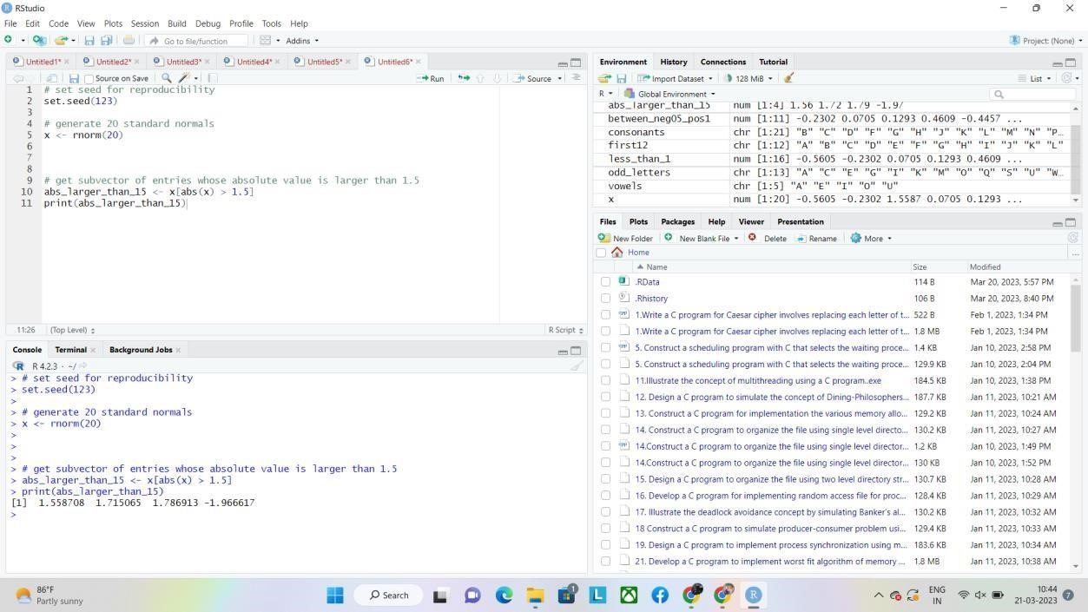

**Program:**

**(iii) the entries whose absolute value is larger than 1.5.**

**# set seed for reproducibility set.seed(123)**

**# generate 20 standard normals x**

**<- rnorm(20)**

**# get subvector of entries whose absolute value is larger than 1.5 abs_larger_than_15 <- x[abs(x) > 1.5] print(abs_larger_than_15) output:**

> # set seed for reproducibility

> set.seed(123)

>

> # generate 20 standard normals

> x <- rnorm(20)

>

>

>

> # get subvector of entries whose absolute value is larger than 1.5

> abs_larger_than_15 <- x[abs(x) > 1.5] > print(abs_larger_than_15)

[1] 1.558708 1.715065 1.786913 -1.966617

>

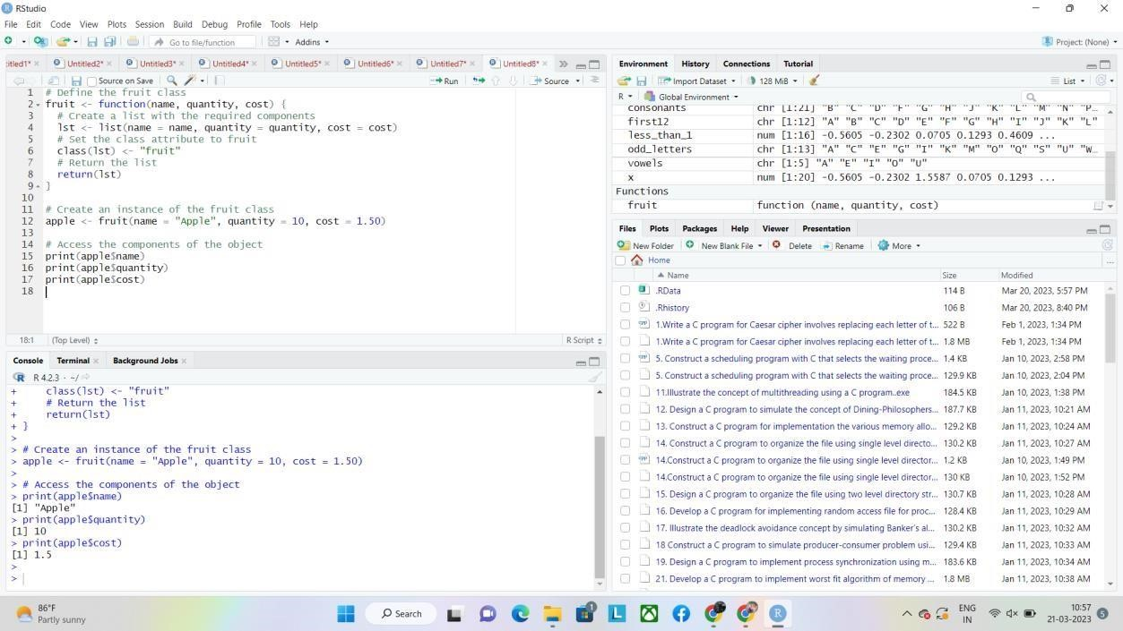

**3. Solve the following system of simultaneous equations using matrix methods.**

**a + 2b + 3c + 4d + 5e = −5**

**2a + 3b + 4c + 5d + e = 2 3a**

**+ 4b + 5c + d + 2e = 5**

**4a + 5b + c + 2d + 3e = 10 5a**

**+ b + 2c + 3d + 4e = 11**

**Program:**

**# Define the matrix A and vector b**

**A <- matrix(c(1, 2, 3, 4, 5,**

**2, 3, 4, 5, 1,**

**3, 4, 5, 1, 2,**

**4, 5, 1, 2, 3,**

**5, 1, 2, 3, 4), nrow = 5, byrow = TRUE) b**

**<- c(-5, 2, 5, 10, 11)**

**# Solve the system using the solve function x**

**<- solve(A, b)**

**# Print the solution vector x**

**X**

**Output:**

> # Define the matrix A and vector b

> A <- matrix(c(1, 2, 3, 4, 5,

+ 2, 3, 4, 5, 1,

+ 3, 4, 5, 1, 2,

+ 4, 5, 1, 2, 3,

+ 5, 1, 2, 3, 4), nrow = 5, byrow = TRUE)

> b <- c(-5, 2, 5, 10, 11)

>

> # Solve the system using the solve function

> x <- solve(A, b)

>

> # Print the solution vector x

> x

[1] 3.5066667 0.1066667 -0.6933333 -0.2933333 -1.0933333 >

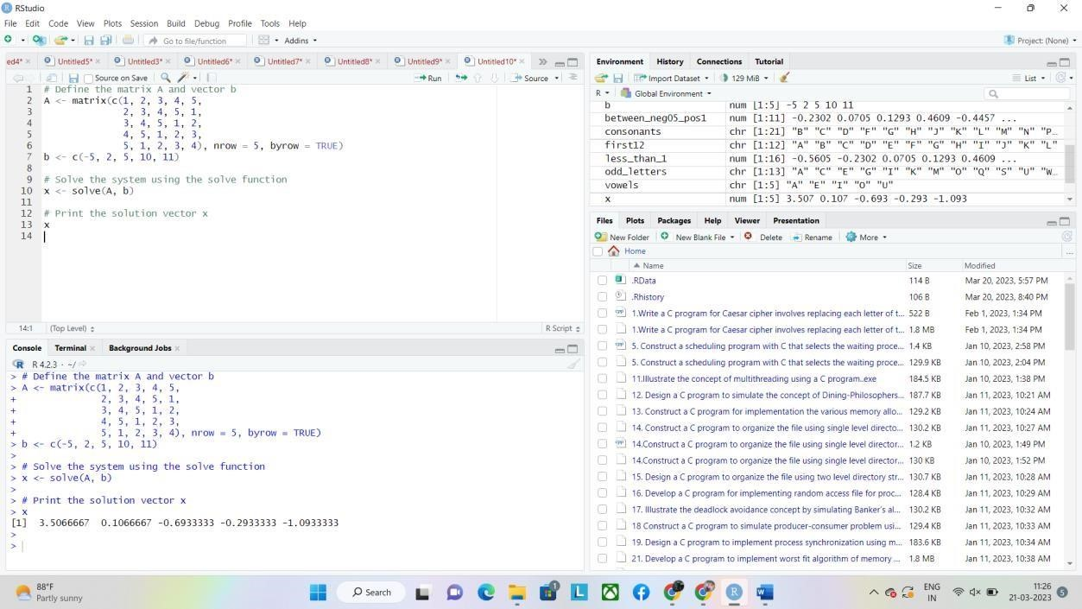

**4. Create a factor object for an apple color such as &#39;green&#39;,**

**&#39;green&#39;, &#39;yellow&#39;, &#39;red&#39;, &#39;red&#39;,**

**&#39;red&#39;,&#39;**

**green&#39;. Print the factor and applying the nlevels function to know the number of**

**distinct values**

**program:**

**# create the factor object**

**apple_colors <- factor(c('green', 'green', 'yellow', 'red', 'red', 'red', 'green'))**

**# print the factor object print(apple_colors)**

**# apply the nlevels function nlevels(apple_colors) output:**

> # create the factor object

> apple_colors <- factor(c('green', 'green', 'yellow', 'red', 'red', 'red', 'green'))

>

> # print the factor object

> print(apple_colors)

[1] green green yellow red red red green

Levels: green red yellow

> # apply the nlevels function

> nlevels(apple_colors)

[1] 3  >

>

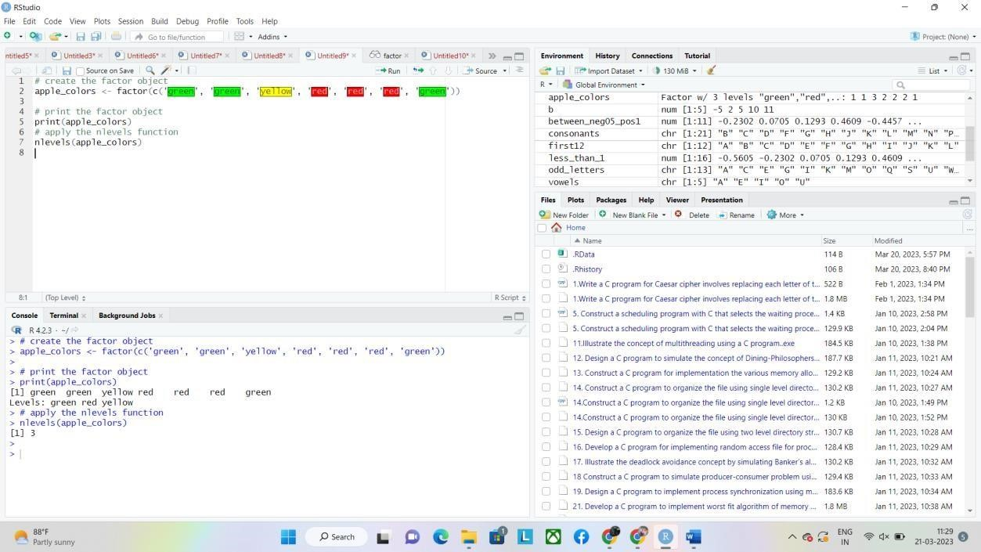

**5. Create an S3 object of class fruit contains a list with following required components such as name, quantity, cost and also Define and create s4 objects.Define a reference**

**class of fruit program: # Define the fruit class**

**fruit <- function(name, quantity, cost) { # Create a list**

**with the required components lst <- list(name = name, quantity = quantity, cost = cost) # Set the class attribute to fruit class(lst) <- "fruit" # Return the list return(lst)**

**}**

**# Create an instance of the fruit class**

**apple <- fruit(name = "Apple", quantity = 10, cost = 1.50)**

**# Access the components of the object print(apple$name)**

**print(apple$quantity) print(apple$cost)**

**output:**

> # Define the fruit class

> fruit <- function(name, quantity, cost) {

+ # Create a list with the required components

+ lst <- list(name = name, quantity = quantity, cost = cost)

+ # Set the class attribute to fruit

+ class(lst) <- "fruit"

+ # Return the list

+ return(lst)

+ }

>

> # Create an instance of the fruit class

> apple <- fruit(name = "Apple", quantity = 10, cost = 1.50) >

> # Access the components of the object

> print(apple$name)

[1] "Apple"

> print(apple$quantity)

[1] 10

> print(apple$cost)

[1] 1.5  >

>

